

Mandatory Public Disclosure
A. GENERAL INFORMATION
SL NO. | INFORMATION | DETAILS
1 | NAME OF THE SCHOOL | ST.JOSEPH’S CENTRAL SCHOOL
2 | AFFILIATION NUMBER | 930074
3 | SCHOOL CODE | 75076
4 | COMPLETE ADDRESS WITH PIN CODE | ST.JOSEPH’S CENTRAL SCHOOL MUNDAKAYAM P.O KOTTAYAM DIST.  KERALA-686513
5 | PRINCIPAL NAME & QUALIFICATION | Fr. SUDEEP SEBASTIAN (MA,B.Ed)
6 | SCHOOL EMAIL- ID | stjosephscentralschool@gmail.com
7 | CONTACT DETAILS | LANDLINE: +91 4828-272253  MOBILE:+ 919446442322
B. DOCUMENTS AND INFORMATION
SL.NO. | DOCUMENTS AND INFORMATION |  | UPLOAD DOCUMENTS
1 | COPIES OF AFFILIATION / UPGRADATION LETTER  AND RECENT EXTENSION OF AFFILIATION, IF ANY |  | Click here to View
2 | COPIES OF SOCIETIES / TRUST / COMPANY REGISTRATION / RENEWAL CERTIFICATE. AS  APPLICABLE |  | Click here to View
3 | COPY OF NO OBJECTION CERTIFICATE (NOC) ISSUED, IF APPLICABLE, BY THE STATE GOVT./ UT |  | Click here to View
4 | COPIES OF RECOGNITION CERTIFICATE UNDER RTE ACT, 2009, AND IT’S RENEWAL IF  APPLICABLE |  | Click here to View
5 | COPY OF VALID BUILDING SAFETY CERTIFICATE AS PER THE NATIONAL BUILDING CODE |  | Click here to View
6 | COPY OF VALID FIRE SAFETY CERTIFICATE ISSUED BY THE COMPETENT AUTHORITY |  | Click here to View
7 | COPY OF THE DEO CERTIFICATE  SUBMITTED BY THE SCHOOL FOR AFFILIATION / UPGRADATION / EXTENSION OF AFFILIATION OR |  | Click here to View

 | SELF CERTIFICATION BY SCHOOL
8 | COPIES OF VALID WATER, HEALTH AND SANITATION CERTIFICATES | Click here to View
C. RESULT AND ACADEMICS
SL.NO. | DOCUMENTS / INFORMATION | UPLOAD  DOCUMENTS
1 | FEES STRUCTURE OF THE SCHOOL | Click here to View
2 | ANNUAL ACADEMIC CALENDAR | Click here to View
3 | LIST OF SCHOOL MANAGEMENT COMMITTEE (SMC) | Click here to View
4 | LIST OF PARENTS TEACHERS’ ASSOCIATION (PTA) MEMBERS | Click here to View
5 | LAST THREE-YEAR RESULT OF THE BOARD EXAMINATIONS AS PER  APPLICABILITY

RESULT CLASS X
 |  |  | SR. NO |  |  |  | YEAR | NO. OF REGISTERED  STUDENTS |  |  | NO. OF STUDENTS PASSED |  |  |  | PASS PERCENTAGE
 |  |  | 1 |  |  |  | 2023 | 116 |  |  | 116 |  |  |  | 100%
 |  |  | 2 |  |  |  | 2024 | 90 |  |  | 90 |  |  |  | 100%
 |  |  | 3 |  |  |  | 2025 | 91 |  |  | 91 |  |  |  | 100%
RESULT CLASS XII
 | S.NO | YEAR |  |  |  | NO. OF REGISTERED STUDENTS |  |  |  | NO.OF STUDENTS  PASSED |  | PASS PERCENTAGE
 | 1 | 2023 |  |  |  | 64 |  |  |  | 64 |  | 100%
 | 2 | 2024 |  |  |  | 61 |  |  |  | 61 |  | 100%
 | 3 | 2025 |  |  |  | 47 |  |  |  | 47 |  | 100%
D. STAFF (TEACHING)
 | SR.NO. |  |  | INFORMATION |  |  |  |  |  |  |  |  |  | DETAILS
 | 1 |  |  | PRINCIPAL |  |  |  |  |  |  |  |  |  | Fr. SudeepSebastian
 | 2 |  |  | TOTAL NO. OF TEACHERS
 |  |  |  |  | # PGT |  |  |  | 18
 |  |  |  |  | # TGT |  |  |  | 16

 |  |  | # PRT | 17
 |  |  | # PET  # NTT | 2  9
 |  | TOTAL 62
 | 3 | TEACHERS SECTION RATIO |  |  |  | 1:1.5
 | 4 | DETAILS OF SPECIAL EDUCATOR |  |  |  | NA
 | 5 | DETAILS OF COUNSELLOR AND WELLNESS  TEACHER |  |  |  | 1

E: SCHOOL INFRASTRUCTURE
 | SR.NO. | INFORMATION | DETAILS
 | 1 | TOTAL CAMPUS AREA OF THE SCHOOL (IN SQUARE MTR.) | 10117.141 sq.  mtr
 | 2 | NO. AND SIZE OF THE CLASS ROOMS (IN SQ. MTR) | 62 – 40 sq.mtr  6 – 60 sq.mtr
 | 3 | NO. AND SIZE OF LABORATORIES INCLUDING COMPUTER LABS (IN SQ.MTR)
 | PHYSICS LAB |  |  | 72 sq.mtr
 | CHEMISTRY LAB |  |  | 80 sq.mtr.
 | BIOLOGY LAB |  |  | 72 sq. mtr
 | COMPUTER LAB |  |  | 49 sq. mtr
 | MATHEMATICS LAB |  |  | 49 sq.mtr
 | 4 | INTERNET FACILITY ( Y / N) |  | YES
 | 5 | NO. OF GIRLS TOILETS |  | 90
 | 6 | NO. OF BOYS TOILETS |  | 85
 | 7 | LINK OF YOUTUBE VIDEO OF THE INSPECTION OF SCHOOL COVERING THE INFRASTRUCTURE OF THE SCHOOL

AFFILIATION LETTER

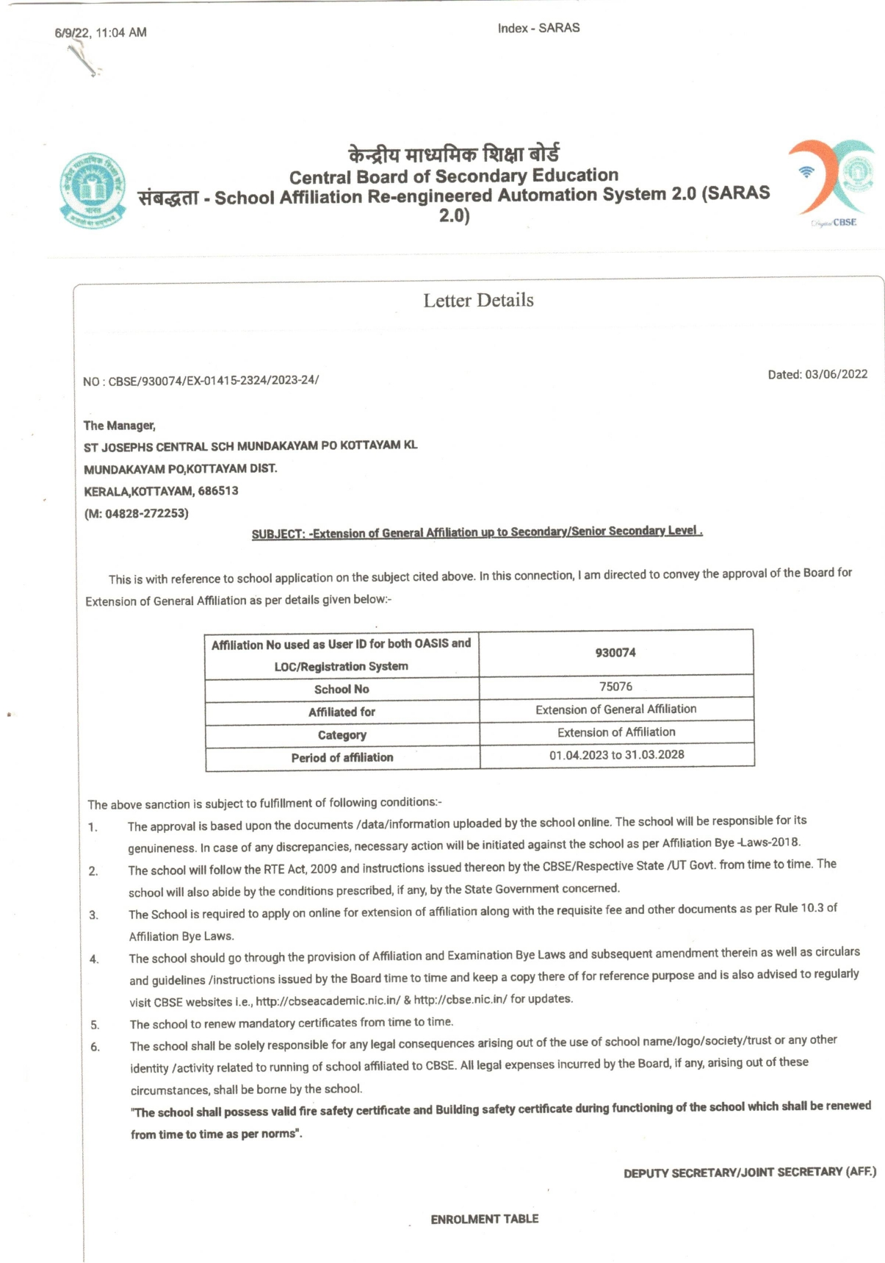
SOCIETIES REGISTRATION

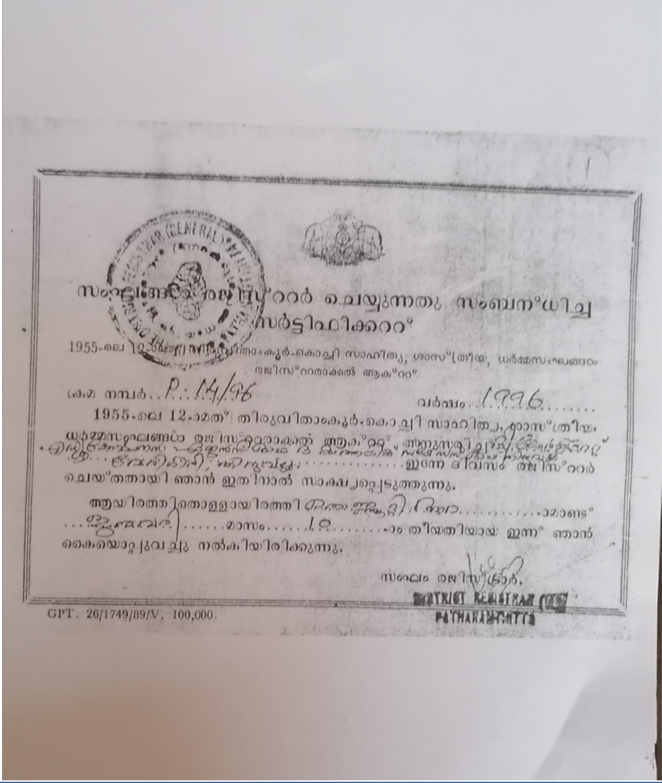

NO OBJECTION CERTIFICATE (NOC)

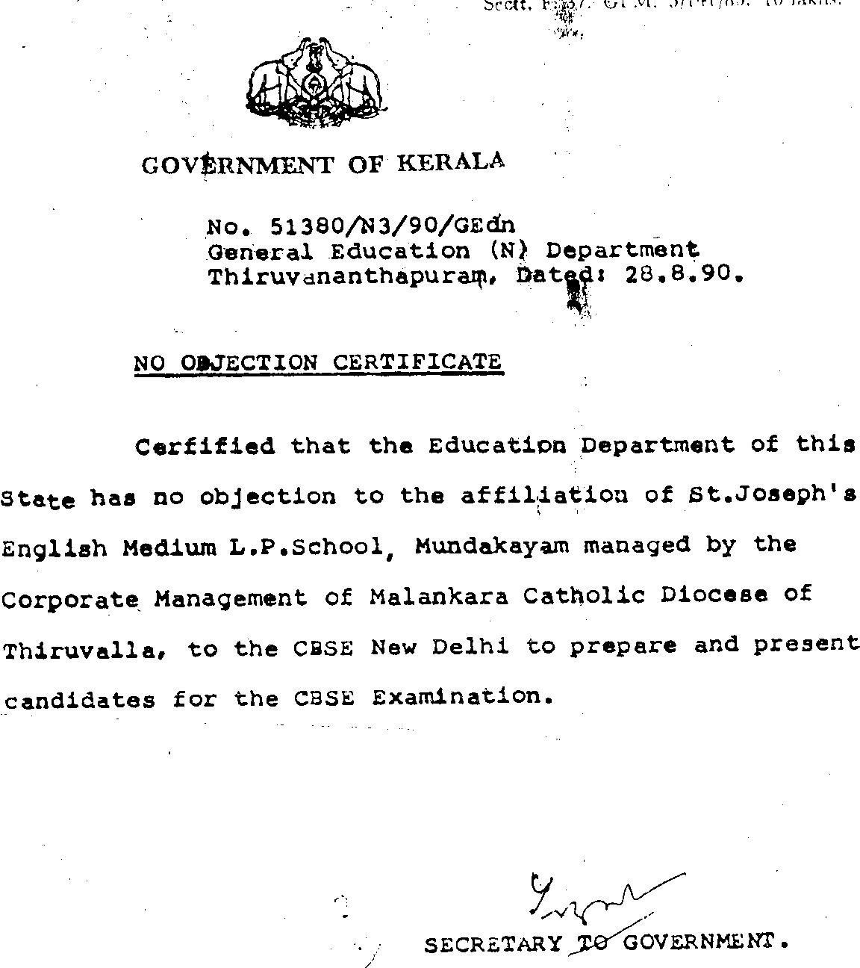
FIRE AND SAFETY CERTIFICATE

BUILDING SAFETY

CERTIFICATE

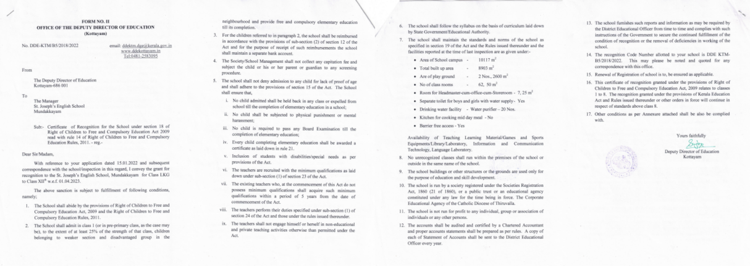
WATER, HEALTH AND SANITATION CERTIFICATES





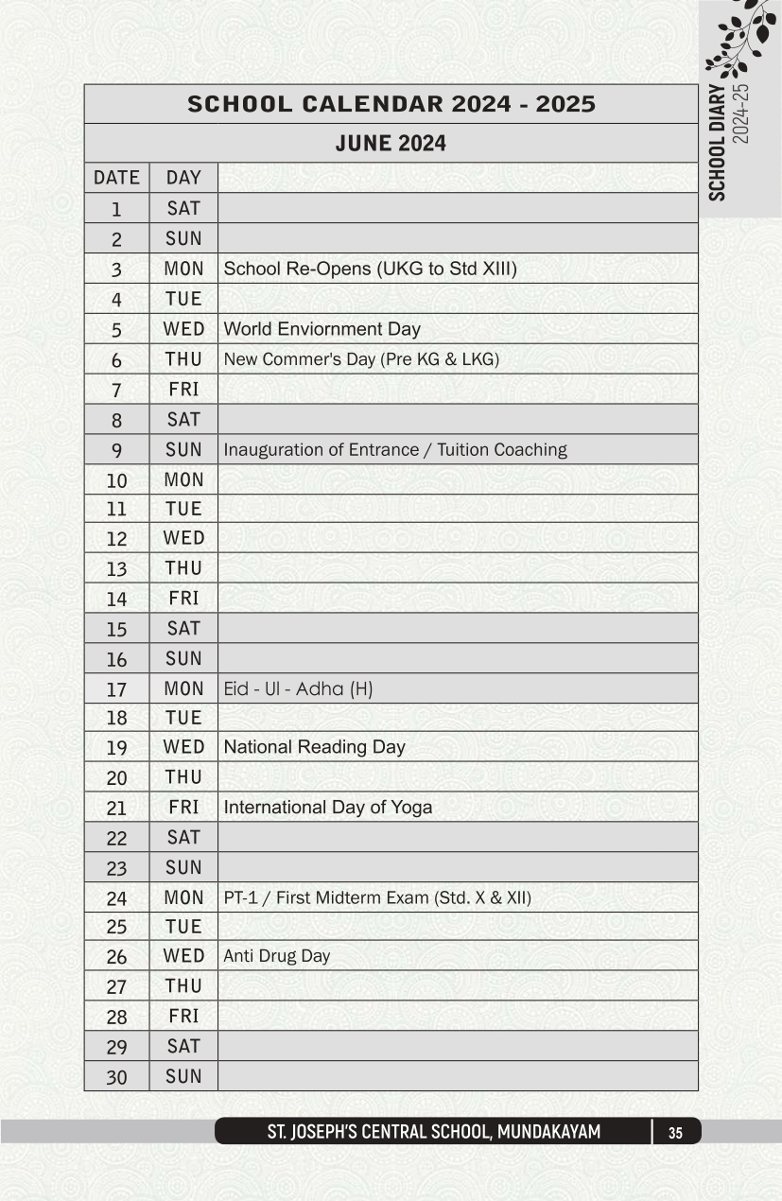

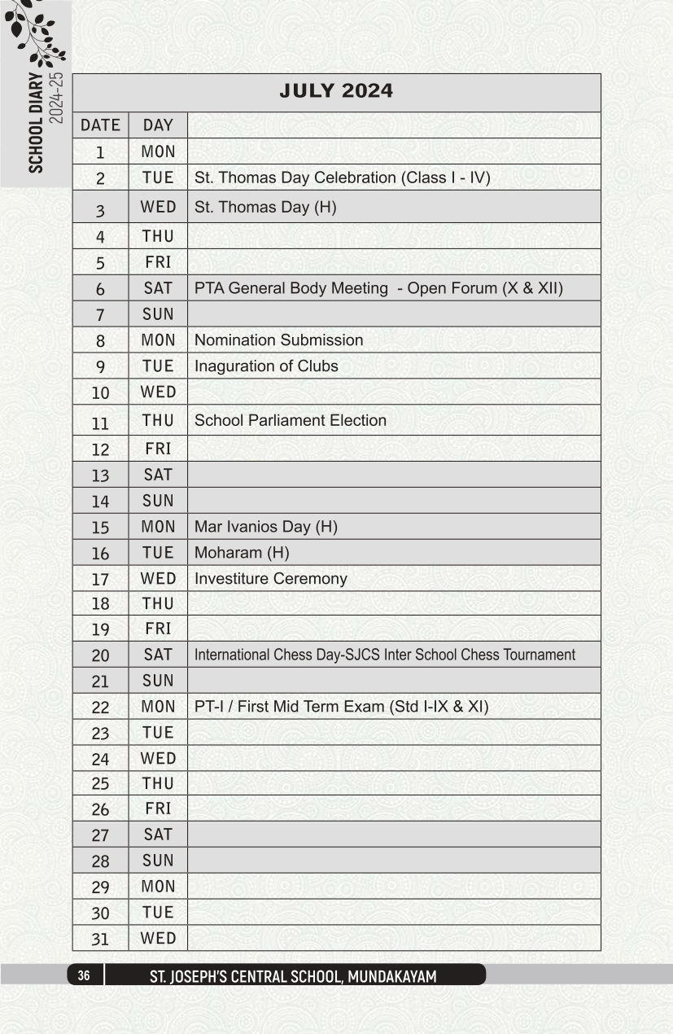

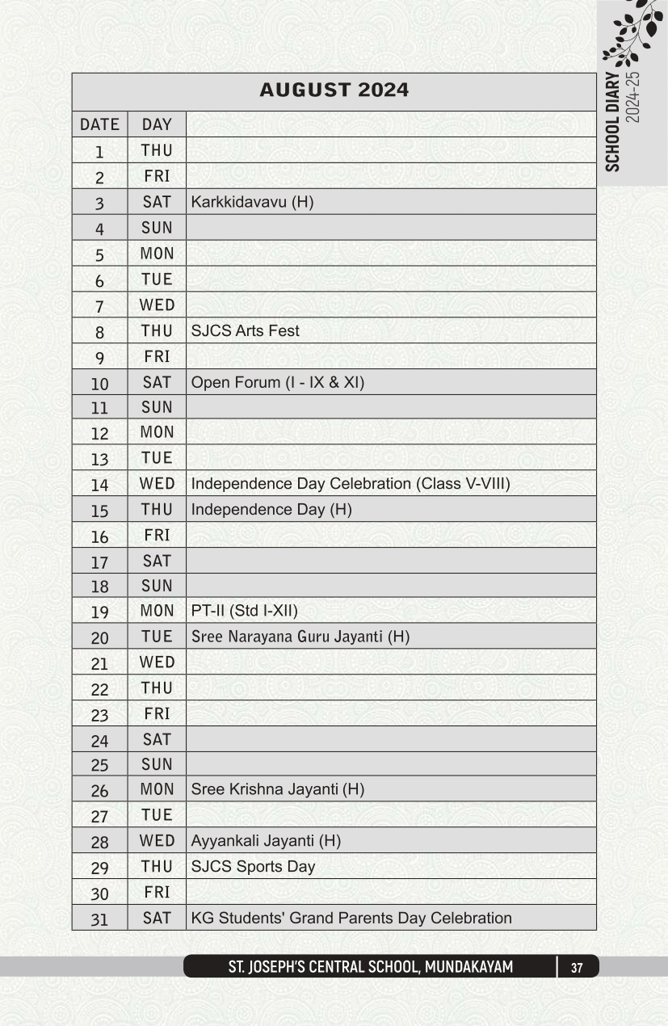

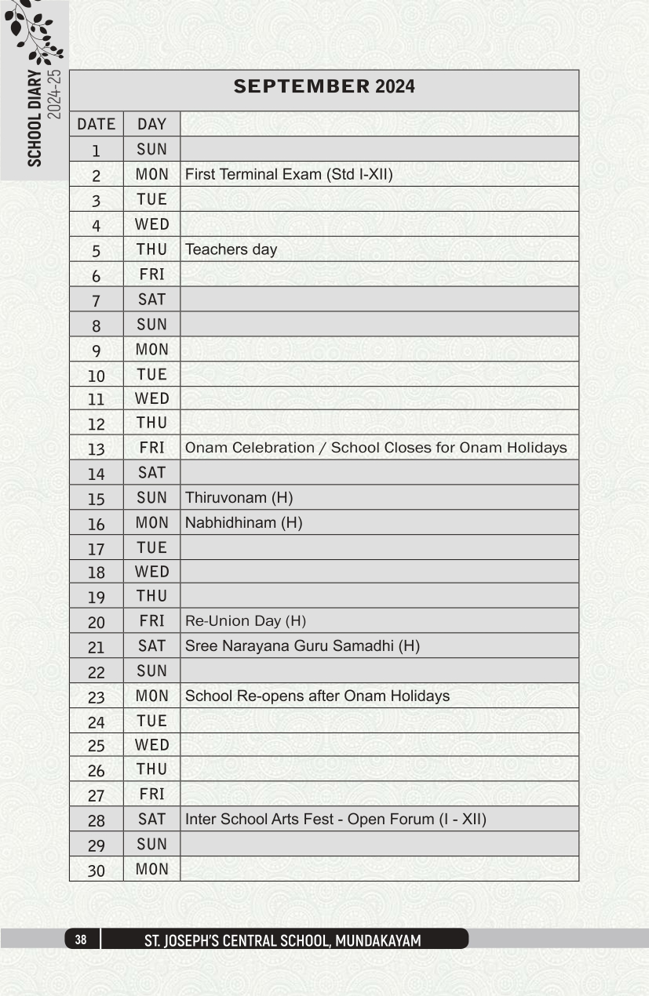

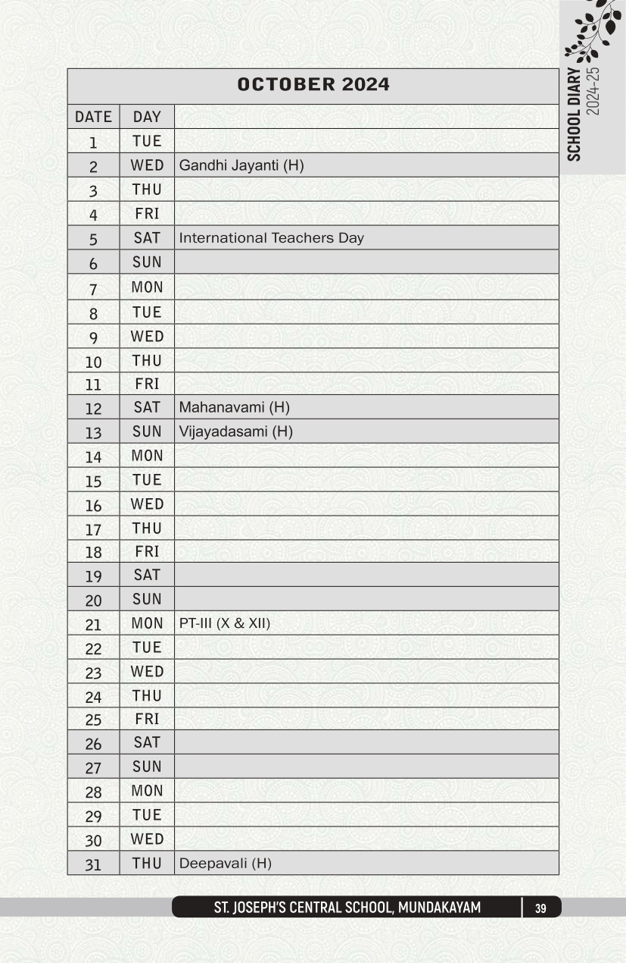

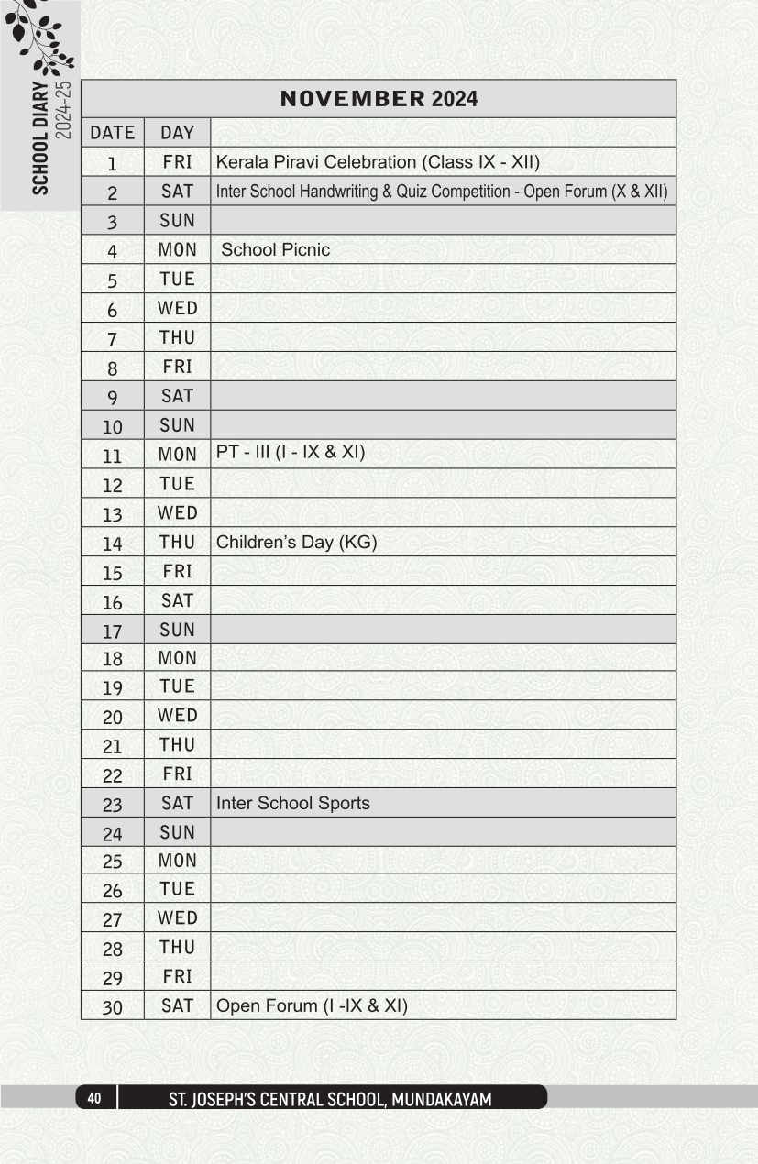

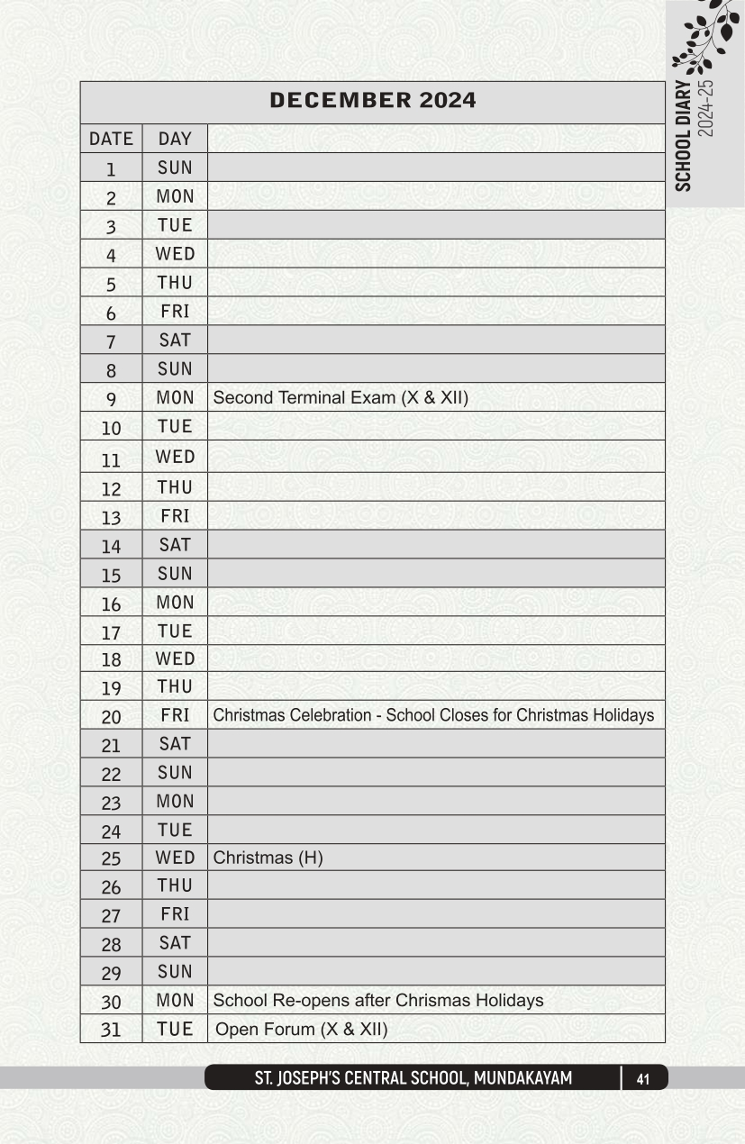

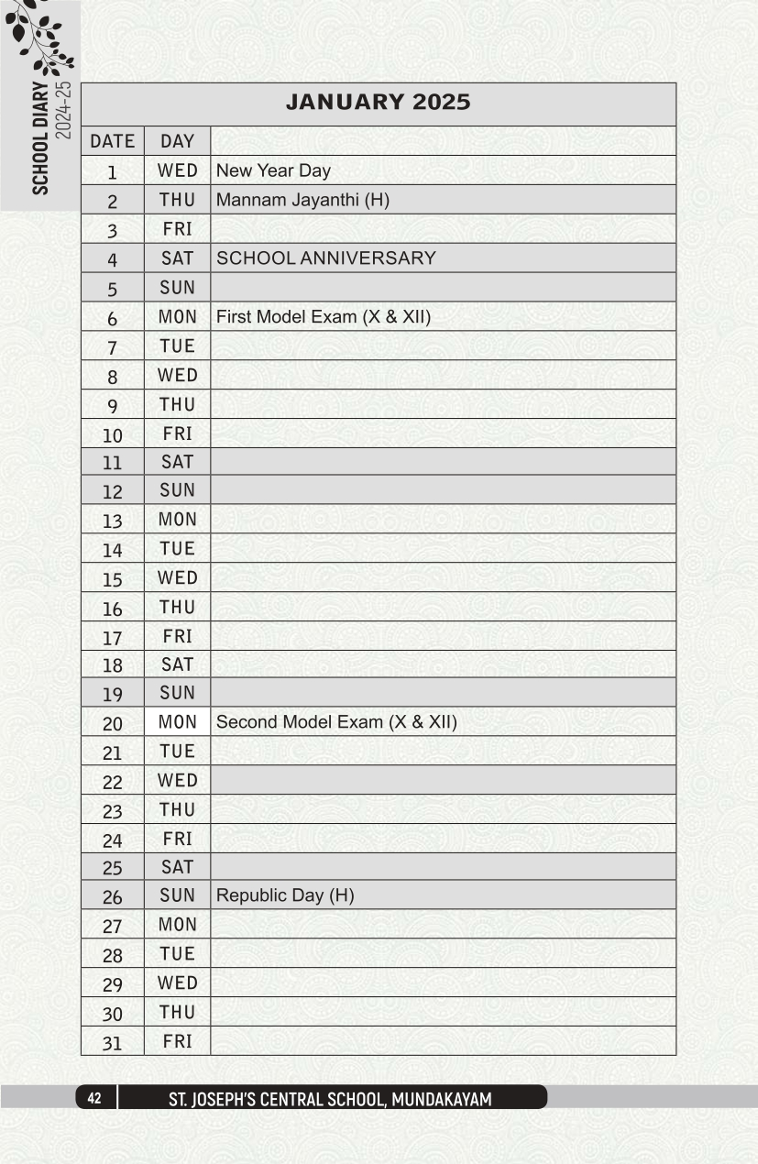
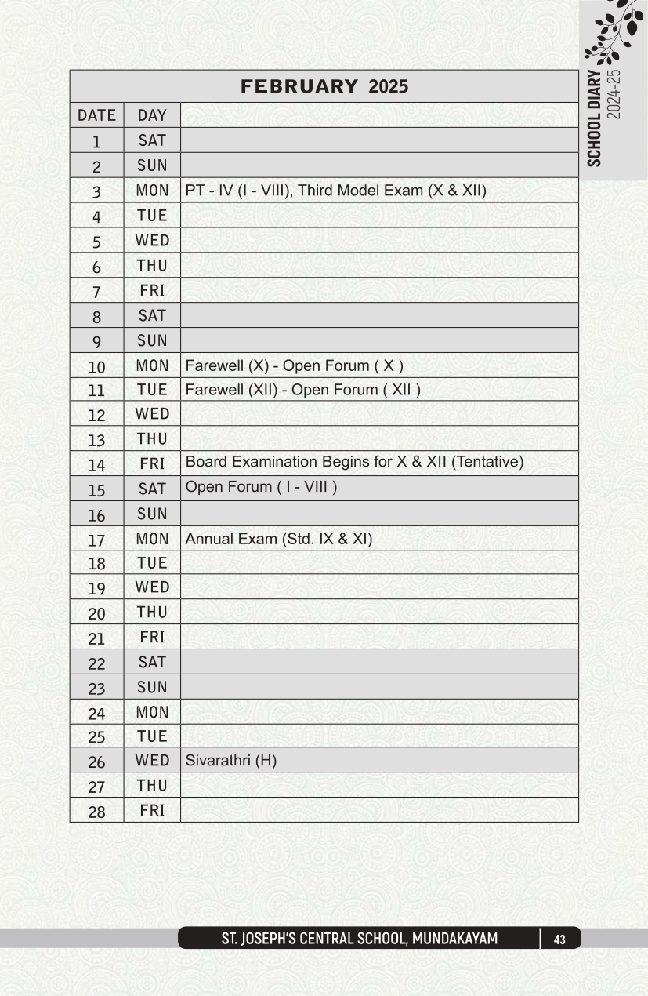

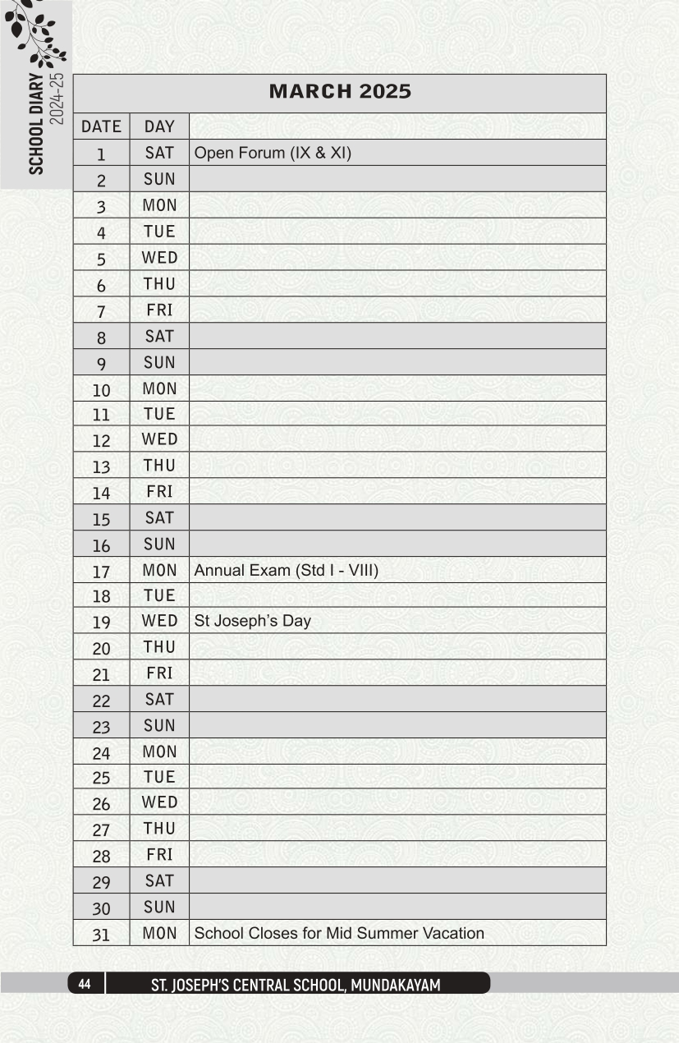

SCHOOL MANAGEMENT COMMITTEE (SMC)

SL.  No. | MEMBER | DESIGNATION IN SMC
1. | MOST. REV.DR.THOMAS MAR KOORILOS | CHAIRMAN
2. | FR. JOSE MANNORKIZHAKETHIL | MANAGER
3. | FR. MATHAI MANNORVADAKKETHIL | LOCAL MANAGER
4. | FR. SUDEEP SEBASTIAN | SECRETARY
5. | FR. DR. ISAAC PARAPPALLIL | ADVISORY BOARD
6. | Mr. JOHN T J | ADVISORY BOARD
7. | MR. JOSEPH SEBASTIAN | TEACHER'S REPRESENTATIVE(MALE)
8. | MRS. ALICEKUTTY ABRAHAM | TEACHER'S REPRESENTATIVE(FEMALE)
9. | MR. GIGI NICHOLAS | PTA PRESIDENT
10. | MRS. SWAPNA ROY | PTA EXECUTIVE MEMBER
11. | Fr. CHERIAN KOTTAYIL | SMC MEMBER
12. | MRS. JOLLY P C | SMC MEMBER
13. | DR. CILLA ABRAHAM | SMC MEMBER
14. | MR. R G NANDHAKUMAR | SMC MEMBER
15. | DR. JOY JOSEPH | SMC MEMBER
16. | MRS.G BEENA | SMC MEMBER
17. | MR. ANTONY KURUVILA | SMC MEMBER

LIST OF P.T.A EXECUTIVE MEMBERS (2025-26)

SL. NO | CLASS | NAME OF THE MEMBER | DESIGNATION | MOBILE NO.
1. | XII | Mr.Thomas Joseph | MEMBER | 7012095480
2. | XI | Mr. Sudheesh M S | MEMBER | 9745664626
3. | X | Mr. Gigi Nicholas | MEMBER | 9447208722
4. | IX | Mrs.Swapna Roy | MEMBER | 9497176636
5. | VIII | Smijith V R | MEMBER | 9676298105
6. | VII | Mrs. Jincy Mathew | MEMBER | 9562139092
7. | VI | Mr. Shajir A | MEMBER | 9995364905
8. | V | Mr. Shihabudeen P Y | MEMBER | 6235369245
9. | IV | Mrs. Jincy Thomas | MEMBER | 7025295047
10. | III | Mr. Alexander M A | MEMBER | 6238261504
11. | II | Chinnu Soman | MEMBER | 8157906068
12. | I | Mr. Shaiju Mathew | MEMBER | 9544136063
13. | UKG | Mrs. Beema Rasheed | MEMBER | 9656966936
14. | LKG | Mr. Gem Thomas | MEMBER | 8281012257
15 | PRE KG | Mrs. Remya Renjith | MEMBER | 9847217218
16. | Fr.Mathai Mannoorvadakkethil |  | Manager | 9446329068
17. | Fr.Sudeep Sebastian |  | Principal | 9446442322
18. | Mr. Antony Kuruvila |  | Vice Principal | 9446223354
19. | Mr.Joseph Sebastian |  | Staff Secretary | 9495234204
20. | Mr. Thomas P J |  | Section In-Charge-HSS | 9447852042
21. | Mrs. Sreelakshmi K B |  | Section In-Charge-Up | 8281314243
22. | Mrs. Sindhu S.R |  | Section In-Charge-Lp | 9947599637
23. | Mrs.Rinu k Mathew |  | Section In-Charge-Kg | 9746430490

